19.40: a) The product 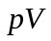 increases, and even for a non-ideal gas, this indicates a temperature increase. b) The work is the area in the 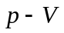 plane bounded by the blue line representing the process and the vericals at 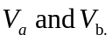 The area of this trapeziod is

